  Box 2415  Edmonton, AB T5J 2S5  Fax: 780-427-5863 or 1-800-661-1993  contact.centre@wcb.ab.ca | **Select form number**  OCCUPATIONAL THERAPY SERVICES  Hand Therapy
WORKER DETAILS |  |  | Provider reference number | WCB claim number  [Claim#]
Surname  [Surname] |  | First name and initial  [First name] |  | Date of birth (yyyy/mm/dd)
Assessment date (yyyy/mm/dd) |  | Report date (yyyy/mm/dd) |  | Date of accident (yyyy/mm/dd)

Compensable conditions (please specify, based on referral form):

Non-compensable conditions impacting return to work (please specify, based on referral form):

Service delivery
☐ In-person ☐ Combination* ☐ Virtual*
*An evaluation was completed via telehealth. Informed verbal consent was obtained from this worker to communicate and provide care using virtual care and other communication tools. This worker has been informed of the risks related to unauthorized disclosure or interception of personal health information and steps they can take to help protect their information.
RECOMMENDATIONS
☐ Further medical investigations, treatment, or other recommendations are required
Details: Specify what is recommended - hand therapy treatment, OT, RTW services, etc. If none, enter “N/A”
☐ Treatment extension request (requires approval by HCS)
Number of units requested:
Include reasoning for requesting an extension and provide details on anticipated outcome.
☐ No further recommendations

Case conference date(s):
Please provide details of case conference(s). If none, enter “N/A”
TREATMENT GOALS
Goal  (i.e., return to full function, improve range of motion, reduction of pain, etc.) | Method  (i.e., specific activity or exercises, ergonomic modification, etc.) | Timeframe  (i.e. three visits, one month, etc.)
Additional information
Additional treatment and/or goal-setting details; if none, enter “N/A”
BACKGROUND INFORMATION
Summary of injury
Include information about MOI, diagnosis, diagnostic testing, claim-related surgery, and/or previous treatment.

Dominant hand: ☐ Left ☐ Right ☐ Ambidextrous
Splint use: ☐ Yes ☐ No
Details of splint and/or splint use; if none, enter “N/A”
Job information
Job attached: ☐ Yes ☐ No | Currently working: ☐ Yes ☐ No | Level: Choose an item.
Restrictions and work abilities
Restrictions: Select one | Complicating factors affecting recovery: ☐ Yes ☐ No
List restrictions. If none, enter “N/A” | If yes, describe
Can modified or alternate work be performed? ☐ Yes ☐ No ☐ N/A
If yes, specify details

DOA functional level |  | Current level required |  | Outcome level required
NOC strength level | Frequency | NOC strength level | Frequency | NOC strength level | Frequency
Select one | Select one | Select one | Select one | Select one | Select one
ASSESSMENT INFORMATION
Subjective complaints and affected activities of daily living
Include impact on job duties; if none, enter “N/A”

Measure | Initial ratings | Discharge ratings | Interpretation
Visual Analog Scale (VAS) | /100 | /100 | Higher scores indicate greater level of pain intensity  Mild: 44/100 | Moderate: 52/100 | Severe: 66/100
Objective observations
Include details of skin and nail condition, including: open wounds, colour, temperature, hidrosis, atrophy, deformity, cold tolerance, etc.

Provider’s name |  | Telephone number |  | Date (yyyy/mm/dd)

***If completing manually, delete this section before submitting***
ADDENDUM – ASSESSMENT DETAILS
Edema:  Circumference |  |  |  |  |  |  | D1  IPJ |  |  |  |  | D2  PIPJ / DIPJ |  |  |  |  | D3  PIPJ / DIPJ |  |  |  |  |  | D4  PIPJ / DIPJ |  |  |  | D5  PIPJ / DIPJ
Hand diagram may be used for circumference reporting |  |  |  |  | Right
 |  |  |  |  | Left
Wrist: R / L |  |  |  |  |  |  |  |  |  |  |  |  | MPJ Circumference: R / L
 |  | R AROM/PROM L |  |  |  |  |  |  | Digits: R L AROM PROM (EX/FL)
Strength |  | Shoulder |  |  |  |  |  |  |  |  | MP |  |  |  |  | PIP |  |  |  | DIP |  |  |  |  | TAM |  |  | TPM
/ |  | / FF / |  |  |  |  |  |  | D2 |  | / |  |  |  |  | / |  |  |  | /
/ |  | / ABD / |  |  |  |  |  |  | D3 |  | / |  |  |  |  | / |  |  |  | /
/ |  | / IR / |  |  |  |  |  |  | D4 |  | / |  |  |  |  | / |  |  |  | /
/ |  | / ER / |  |  |  |  |  |  | D5 |  | / |  |  |  |  | / |  |  |  | /
/ |  | Elbow |  |  |  |  |  |  | Digits: R L AROM PROM (EX/FL)
/ |  | / EX / |  |  |  |  |  |  |  |  | MP |  |  |  |  | PIP |  |  |  | DIP |  |  |  |  | TAM |  |  | TPM
/ |  | / FL / |  |  |  |  |  |  | D2 |  | / |  |  |  |  | / |  |  |  | /
/ |  | / PRO / |  |  |  |  |  |  | D3 |  | / |  |  |  |  | / |  |  |  | /
/ |  | / SUP / |  |  |  |  |  |  | D4 |  | / |  |  |  |  | / |  |  |  | /
/ |  | Wrist |  |  |  |  |  |  | D5 |  | / |  |  |  |  | / |  |  |  | /
/ |  | / EX / |  |  |  |  |  |  | Thumb
/ |  | / FL / |  |  |  |  |  |  | D1 |  | R MP |  |  | R IP |  |  |  | TROM |  |  |  | L MP |  |  |  | L IP |  |  | TROM
/ |  | / UD / |  |  |  |  |  |  | AROM |  | / |  |  | / |  |  |  |  |  |  |  | / |  |  |  | /
/ |  | / RD / |  |  |  |  |  |  | PROM |  | / |  |  | / |  |  |  |  |  |  |  | / |  |  |  | /
Closure Pattern:
Flat fist |  |  |  |  |  |  |  |  |  | CMC ABD R |  |  |  |  |  |  |  |  |  |  | CMC ABD L
Hook |  |  |  |  |  |  |  |  |  | CMC EXT R |  |  |  |  |  |  |  |  |  |  | CMC EXT L
Full fist |  |  |  |  |  |  |  |  |  | Opposition: Select one |  |  |  |  |  |  |  |  |  |  | Edema or Volumeter
Strength |  |  |  |  |  |  |  |  |  | Right (Kg) Avg. |  |  |  |  |  |  |  |  |  |  | Left (Kg) Avg.
Jamar |  |  | Position 1
 |  |  | Position 2
 |  |  | Position 3
 |  |  | Position 4
 |  |  | Position 5
Pinch
Key
Tripod
Tip
Sensation

Testing | EMG  If yes, date: |  |  |  |  | Tinel’s |  |  |  |  |  |  |  |  | Phalen’s |  |  |  |  |  |  |  |  | Finkelstein’s
Neural Tension  Median at what ROM: |  |  |  |  |  |  |  | Ulnar at what ROM: |  |  |  |  |  |  |  |  |  |  | Radial at what ROM:

Left
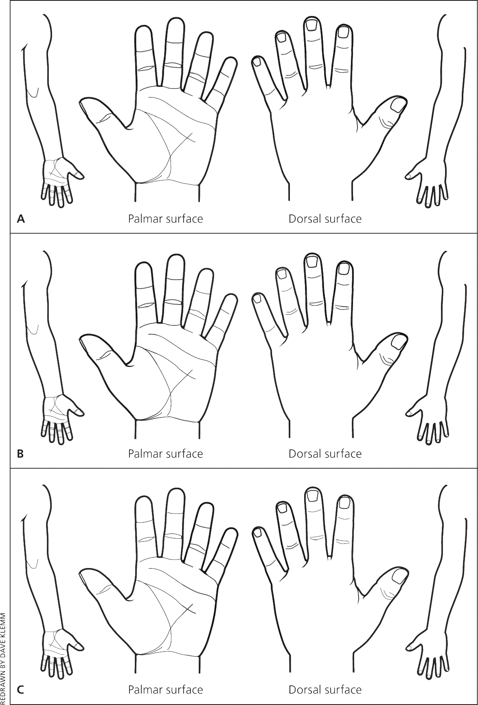

Right

